REQUEST FOR ABSENCE DURING TERM TIME
Requests should be submitted to school at least 2 weeks in advance of the date of absence.

I wish to apply for leave of absence from school, during term time, for my child/children:
Child’s name _____________________________________ Class teacher___________________________________
Child’s name _____________________________________ Class teacher___________________________________
Leave of absence with exceptional circumstances, e.g. compassionate reasons -(please note family holidays will not be authorised) ________________________________________________________________________________________________________________________________________________________________________________________________________________________________________________________________________
(Please specify any other special circumstances you wish to be taken into consideration)
________________________________________________________________________________________________________________________________________________________________________________
The First day my child would be absent ________________ Last day my child would be absent ________________
Number of school days absent in total (i.e. Mon-Fridays, not including weekends): _____________
I confirm that the above activity is essential and cannot take place in the school holidays.

Signed ___________________________________Parent/Carer Date ____________________________

PLEASE NOW HAND THIS INTO THE SCHOOL OFFICE WHO WILL PROCESS YOUR REQUEST

In making a decision, the Headteacher will consider your child’s previous attendance history, their age and stage of education, the time of year (i.e. proximity to any SATs or teacher assessments), the length and reason for the absence, whether the parents are restricted in terms of leave by their employer/employment, and the validity of any other special circumstances stated in the request. Requests will only be granted in exceptional circumstances.

Office use: Number of days already taken………………………. Percentage of attendance to date……………………
❑ REQUEST APPROVED: You have recently requested to take your child out of school during term time. Even though the school does not approve of such absence, it has been agreed in this instance that it is exceptional and will be counted as authorised absence. Please be aware that the governing body regards leave of absence taken during term time that exceeds 10 sessions (5 days) in one academic year as unauthorised absence. Should this happen the matter will be reported to the Local Authority who may issue a penalty notice against you.
❑ REQUEST DENIED: I regret that I am unable to authorise your request in this instance. Requests for leave of absence are never taken lightly and in taking this decision I have considered at length the factors above, in the light of your request. If you wish to discuss this matter further please feel free to make an appointment to see me.
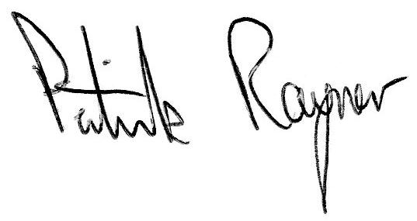
Yours sincerely

Patrick Rayner (Headteacher)

